--1. Display the category, subcategory and count of products in each combination.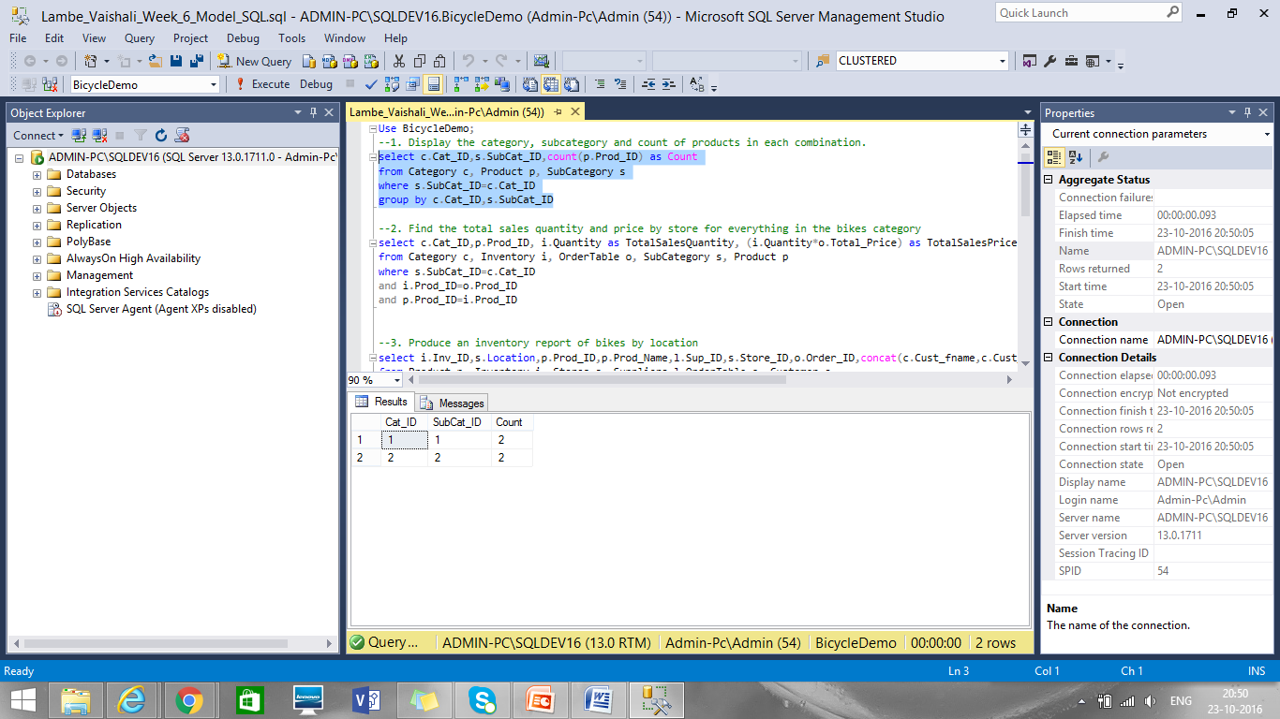

--2. Find the total sales quantity and price by store for everything in the bikes category

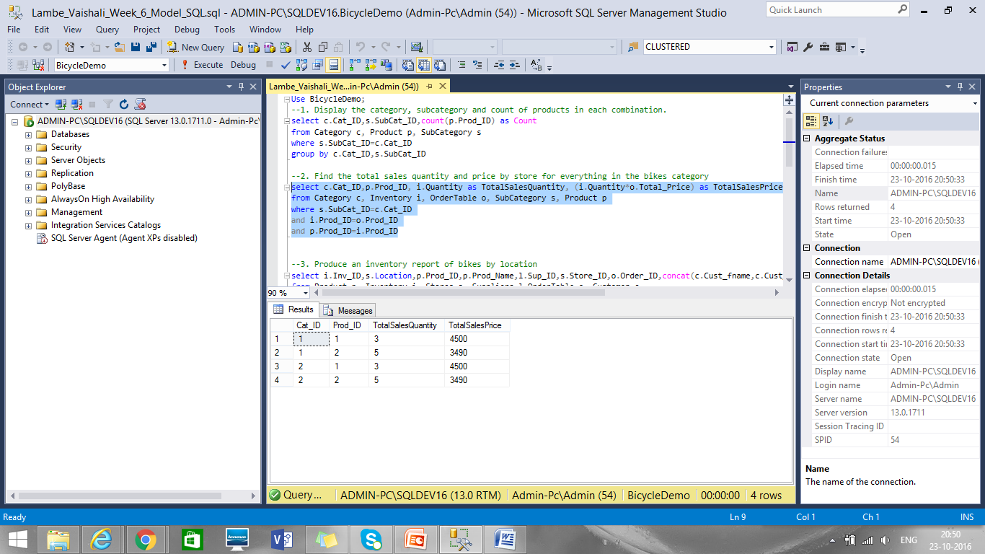

--3. Produce an inventory report of bikes by location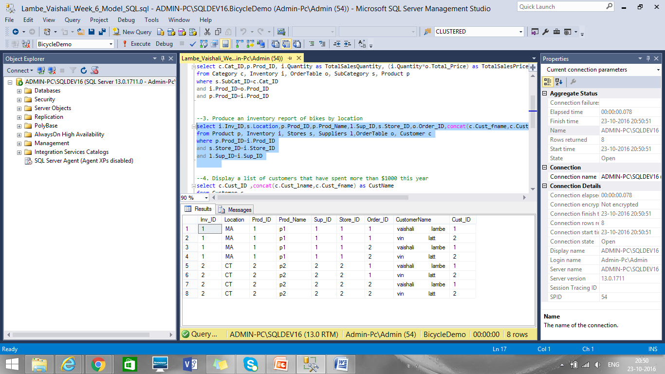

--4. Display a list of customers that have spent more than $1000 this year

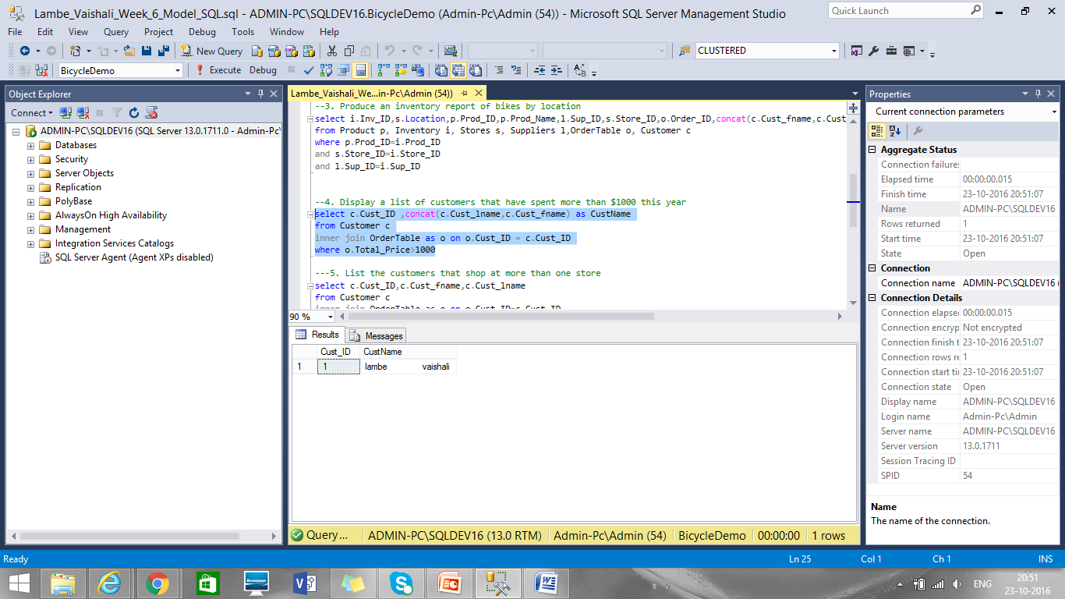

---5. List the customers that shop at more than one store

As there is no customer who orederd in more than one store so result is zero rows

